TASK 1 – Understand the Problem and Identify the Objects 4 Marks
Bloom’s Level: K5 – Evaluate
Analyse the fare problem from the object-oriented point of view.
Discuss:
• The objects in the problem (card, passenger, journey, zone, fare table) and the data and behaviour of each
• How the same problem would be written in a procedural style, and what changes in an object-oriented style
• The basic principles of OOP – encapsulation, abstraction, inheritance and polymorphism – and where each could appear in this system
• The rules every correct journey must satisfy (for example: balance never below Rs 50 after a journey)
Alternative Concept and Complexity Analysis
If the fare system were written in a purely procedural style (global variables and free functions) instead of SmartCard, Journey and FareTable classes, what would the solution be? Analyse whether the time per journey or the memory per card changes (both are O(1)), and compare how much code must be changed when one fare rule changes.
Evidence Expected
A clear object-oriented analysis with objects, their data and behaviour, rules and stated assumptions.

#include <iostream>
using namespace std;

enum class Zone { Inner, Middle, Outer };

class FareTable {
public:
static constexpr int BASE_PAISE[] = {1000, 2000, 3000};
static constexpr int PEAK_SURCHARGE_PERCENT = 20;
static constexpr long long MIN_BALANCE_PAISE = 5000;
static long long baseFare(Zone z) { return BASE_PAISE[static_cast<int>(z)]; }
};

class Passenger {
public:
virtual int concessionPercent() const { return 0; }
virtual ~Passenger() = default;
};
class Student : public Passenger {
public:
int concessionPercent() const override { return 50; }
};
class Senior : public Passenger {
public:
int concessionPercent() const override { return 40; }
};

class Journey {
Zone zone;
int hour;
public:
Journey(Zone z, int h) : zone{z}, hour{h} {}
bool isPeak() const { return (hour >= 8 && hour < 10) || (hour >= 17 && hour < 20); }
long long fare(const Passenger& p) const {
long long f = FareTable::baseFare(zone);
if (isPeak()) f += f * FareTable::PEAK_SURCHARGE_PERCENT / 100;
return f - f * p.concessionPercent() / 100;
}
};

class SmartCard {
long long balancePaise;
public:
explicit SmartCard(long long b) : balancePaise{b} {}
bool canTravel(long long fare) const {
return balancePaise - fare >= FareTable::MIN_BALANCE_PAISE;
}
bool deduct(long long fare) {
if (!canTravel(fare)) return false;
balancePaise -= fare;
return true;
}
long long balance() const { return balancePaise; }
};

int main()
{
SmartCard card{10000};
Passenger regular;
Student student;
Journey j1{Zone::Inner, 12}, j2{Zone::Outer, 9}, j3{Zone::Middle, 10};

const Journey* js[] = {&j1, &j2, &j3};
const Passenger* ps[] = {&regular, &regular, &student};
for (int i = 0; i < 3; i++) {
long long f = js[i]->fare(*ps[i]);
if (card.deduct(f))
cout << "Journey " << i + 1 << ": fare " << f << " paise, balance " << card.balance() << " paise" << endl;
else
cout << "Journey " << i + 1 << ": fare " << f << " paise DENIED, balance " << card.balance() << " paise" << endl;
}
return 0;
}

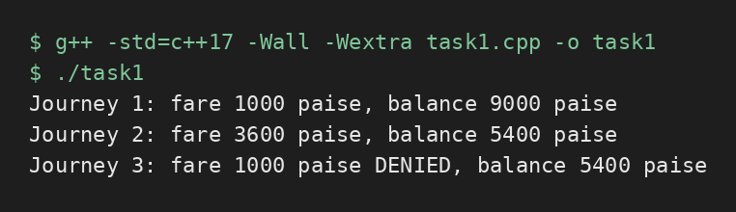

TASK 2 – Use Tokens, Keywords, Identifiers and Constants Correctly 3 Marks
Bloom’s Level: K5 – Evaluate
Define the fares, surcharge and limits so that a revision is made in one place only.
Discuss:
• The five kinds of tokens in your program (keywords, identifiers, constants, operators, punctuators) with examples
• #define, const and constexpr constants, and why constexpr is preferred for the fare table
• enum and enum class for zones, and why enum class is safer
• Naming rules and conventions for identifiers
Alternative Concept and Complexity Analysis
If the fares were written with #define macros instead of constexpr constants and an enum class, what would change? Compare type checking and scope, and analyse the memory used (a macro occupies no storage; a constexpr value usually does not either) and whether the running time is affected.
Evidence Expected
A single, well-named set of constants with a justified choice between #define, const, constexpr and enum class.

#include <iostream>
using namespace std;

#define OLD_SURCHARGE 20

enum class Zone { Inner, Middle, Outer };

constexpr int BASE_PAISE[] = {1000, 2000, 3000};
constexpr int PEAK_SURCHARGE_PERCENT = 20;
constexpr long long MIN_BALANCE_PAISE = 5000;
const int hourNow = 9;

int main()
{
Zone z = Zone::Middle;
long long fare = BASE_PAISE[static_cast<int>(z)];
fare += fare * PEAK_SURCHARGE_PERCENT / 100;

cout << "Base fare (Middle): " << BASE_PAISE[static_cast<int>(z)] << " paise" << endl;
cout << "Peak fare (Middle): " << fare << " paise" << endl;
cout << "Minimum balance: " << MIN_BALANCE_PAISE << " paise" << endl;
cout << "#define value: " << OLD_SURCHARGE << " (no type, no scope)" << endl;
cout << "constexpr size: " << sizeof(PEAK_SURCHARGE_PERCENT) << " bytes, type int" << endl;
cout << "const hourNow: " << hourNow << endl;

// int x = z; // error: enum class does not convert to int
// Zone w = 1; // error: int does not convert to enum class
cout << "Zone as number (needs cast): " << static_cast<int>(z) << endl;
return 0;
}

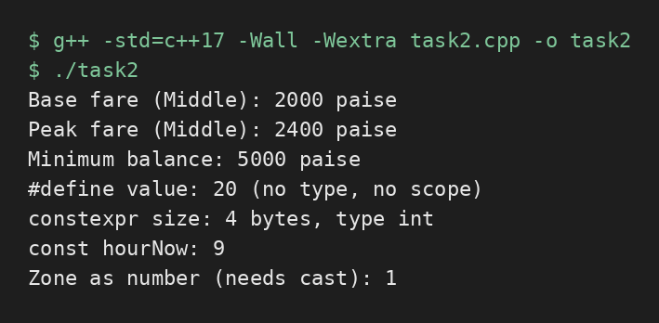

TASK 3 – Choose Data Types and Check Type Compatibility 4 Marks
Bloom’s Level: K5 – Evaluate
Select a C++ data type for every value in the system.
Discuss:
• The type chosen (bool, char, int, long long, unsigned, float, double, auto) for fares, balances, times, zone numbers and journey counts, with sizeof on your system
• Why money should be stored in integer paise and not as double rupees
• Type compatibility rules, and what the compiler does with int, double and bool values in the same expression
• The ranges from <climits> and whether int is enough for a day’s collection across the network
Alternative Concept and Complexity Analysis
If money were stored as double rupees instead of long long paise, what would the solution be? Analyse the time per addition (O(1) in both), the space per value (8 bytes in both), and measure how the rounding error grows when n fares are added.
Evidence Expected
A justified data-type table with sizes and ranges, and evidence of one precision or overflow problem with its resolution.

#include <climits>
#include <iomanip>
#include <iostream>
using namespace std;

int main()
{
cout << "sizeof(bool) = " << sizeof(bool) << endl;
cout << "sizeof(char) = " << sizeof(char) << endl;
cout << "sizeof(int) = " << sizeof(int) << endl;
cout << "sizeof(long long) = " << sizeof(long long) << endl;
cout << "sizeof(float) = " << sizeof(float) << endl;
cout << "sizeof(double) = " << sizeof(double) << endl;
cout << "INT_MAX = " << INT_MAX << endl;
cout << "LLONG_MAX = " << LLONG_MAX << endl;

double d = 0;
long long p = 0;
for (int i = 0; i < 1000000; i++) { d += 0.1; p += 10; }
cout << fixed << setprecision(6);
cout << "double total (Rs) = " << d << endl;
cout << "paise total (Rs) = " << p / 100.0 << endl;

long long total = 3000000LL * 3600;
int bad = static_cast<int>(total);
cout << "long long total = " << total << " paise" << endl;
cout << "int total = " << bad << " paise (overflow)" << endl;
return 0;
}

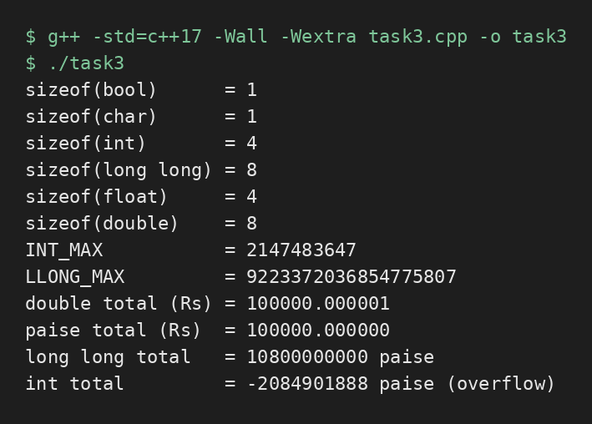

TASK 4 – Control Implicit Conversions 4 Marks
Bloom’s Level: K5 – Evaluate
Identify every place in the program where C++ converts a value from one type to another without being told.
Discuss:
• Integer division and integer-to-double conversion
• Comparison of signed and unsigned values, and the compiler warning it produces • Narrowing conversions, and how brace initialisation (int x{3.7};) prevents them • static_cast and when an explicit cast is needed
Predict the Output
Write the exact output of the program below BEFORE running it. Then compile and run it, and explain every difference between your prediction and the actual output.
#include <iostream>
int main()
{
int a = 7, b = 2;
double c = a / b;
double d = static_cast<double>(a) / b;
std::cout << c << ' ' << d << '\n';
char ch = 'A' + 2;
std::cout << ch << ' ' << ch + 1 << '\n';
bool flag = 5;
std::cout << flag << ' ' << std::boolalpha << flag << '\n';
unsigned int u = 1;
int s = -1;
std::cout << (s < u ? "s < u" : "s >= u") << '\n';
}
My predicted output (write before running):
Explain each line of the actual output, naming the conversion that took place (integer division, char to int promotion, int to bool, signed to unsigned).
Alternative Concept and Complexity Analysis
If every conversion in the program were written explicitly with static_cast (and brace initialisation were used everywhere), instead of relying on implicit conversions, what would the solution be? Analyse whether the running time or memory changes, and which errors are caught at compile time instead of at run time.
Evidence Expected
Identified conversion points with demonstrated surprises, and corrected code using brace initialisation or static_cast.

Program:

#include <iostream>
using namespace std;

int main() {
int a = 7, b = 2;
double c = a / b;
double d = static_cast<double>(a) / b;

cout << c << " " << d << endl;

char ch = 'A' + 2;
cout << ch << " " << ch + 1 << endl;

bool flag = 5;
cout << flag << " ";
cout << boolalpha << flag << endl;

unsigned int u = 1;
int s = -1;
cout << (s < u ? "s < u" : "s >= u") << endl;

return 0;
}

Output:
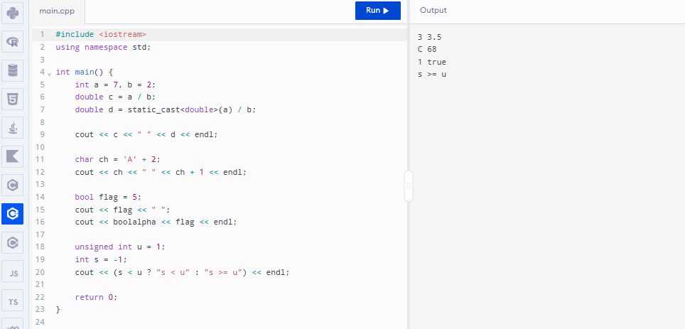

TASK 5 – Write Correct Expressions with the Right Precedence 4 Marks
Bloom’s Level: K5 – Evaluate
Write the expressions for the peak check, the surcharge and the concession.
Discuss:
• Operator precedence and associativity in each expression, including the conditional operator ?: and compound assignment
• The difference between x++ and ++x, and why i = i++ is a mistake
• The result of / and % with negative operands
• Why (hour >= 8 && hour < 10) || (hour >= 17 && hour < 20) is correct and hour >= 8 && hour < 10 || hour >= 17 && hour < 20 is equivalent but harder to read
Predict the Output
Write the exact output of the program below BEFORE running it. Then compile and run it, and explain every difference between your prediction and the actual output.
#include <iostream>
int main()
{
int x = 5, y = 3;
std::cout << x + y * 2 << ' ' << (x + y) * 2 << '\n';
int z = x++ + ++y;
std::cout << z << ' ' << x << ' ' << y << '\n';
std::cout << (x > y ? x : y) << ' ' << x % 4 * 2 << '\n';
std::cout << 10 / 3 << ' ' << 10 % 3 << ' ' << -10 / 3 << ' ' << -10 % 3 << '\n';
int k = 0;
for (int i = 0; i < 10; i += 3) k += i;
std::cout << k << '\n';
}
My predicted output (write before running):
For every line, name the operators involved and the order in which precedence and associativity apply them.
Alternative Concept and Complexity Analysis
If the peak-hour check were done with a lookup table bool peak[24] indexed by the hour, instead of a combined && / || expression, what would the solution be? Analyse the time per check (O(1) in both, but fewer comparisons with the table) and the extra space of 24 bytes.
Evidence Expected
Correct, readable expressions with an operator-by-operator explanation.

Program:

#include <iostream>
using namespace std;

int main() {
int x = 5, y = 3;

cout << x + y * 2 << " " << (x + y) * 2 << endl;

int z = x++ + ++y;
cout << z << " " << x << " " << y << endl;

cout << (x > y ? x : y) << " " << x % 4 * 2 << endl;

cout << 10 / 3 << " " << 10 % 3 << " "
<< -10 / 3 << " " << -10 % 3 << endl;

int k = 0;
for (int i = 0; i < 10; i += 3)
k += i;

cout << k << endl;

return 0;
}

Output:
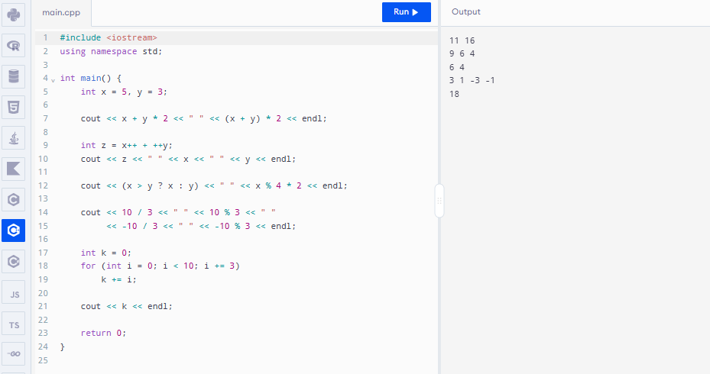

TASK 6 – Design the Control Structures 4 Marks
Bloom’s Level: K5 – Evaluate
Design the decision and looping logic for computing a fare and processing a day’s journeys. Discuss:
• When to use if–else, a switch on the zone, and the conditional operator
• How a for loop, a range-based for loop and a while loop could process the journeys, and which is best
• Where break and continue are needed (for example, skipping an invalid journey) • What happens when no case of a switch matches
Write pseudocode for the fare computation following the SIMATS Engineering – Standard for Algorithmic Pseudocode before writing C++ code.
Complete the Code
Complete TODO 1 and TODO 2 below using a switch statement and integer paise, and execute the program.
#include <iomanip>
#include <iostream>
enum class Zone { Inner, Middle, Outer };
constexpr int BASE_PAISE[] = {1000, 2000, 3000}; // Rs 10, Rs 20, Rs 30 constexpr int PEAK_SURCHARGE_PERCENT = 20;
constexpr long long MIN_BALANCE_PAISE = 5000; // Rs 50 must remain on the card
long long fare(Zone z, bool peak)
{
// TODO 1: Use a switch on z to pick the base fare from BASE_PAISE, then add // PEAK_SURCHARGE_PERCENT % in peak hours using integer arithmetic only
}
bool canTravel(long long balance, long long f)
{
// TODO 2: Return true only if the balance left after paying the fare is at least // MIN_BALANCE_PAISE

}
int main()
{
long long balance = 10000; // Rs 100.00 in paise
struct Trip { Zone zone; bool peak; };
Trip trips[] = {{Zone::Inner, false}, {Zone::Outer, true}, {Zone::Middle, false}}; for (const Trip& t : trips) {
long long f = fare(t.zone, t.peak);
if (canTravel(balance, f)) {
balance -= f;
std::cout << "Fare Rs " << f / 100 << '.' << std::setw(2)
<< std::setfill('0') << f % 100 << std::setfill(' ');
} else {
std::cout << "Denied (low balance)";
}
std::cout << " balance Rs " << balance / 100 << '\n';
}
}
Expected output:
Fare Rs 10.00 balance Rs 90
Fare Rs 36.00 balance Rs 54
Denied (low balance) balance Rs 54
Add a journey at exactly 10 AM and at exactly 8 PM and check that your peak rule treats them correctly.
Alternative Concept and Complexity Analysis
If the base fare were looked up from an array indexed by the zone (constexpr long long FARE[] = {1000, 2000, 3000}) instead of a switch, what would the solution be? Analyse the time per lookup (O(1) in both; the switch may become a jump table), the space of the array, and how each design copes with a fourth zone.
Evidence Expected
Pseudocode and C++ control structures for the fare computation, with justified choices.

Program:

#include <iostream>
#include <iomanip>
using namespace std;

enum class Zone { Inner, Middle, Outer };

constexpr int BASE_PAISE[] = {1000, 2000, 3000};
constexpr int PEAK_SURCHARGE_PERCENT = 20;
constexpr long long MIN_BALANCE_PAISE = 5000;

long long fare(Zone z, bool peak) {
int f = 0;

switch (z) {
case Zone::Inner: f = BASE_PAISE[0]; break;
case Zone::Middle: f = BASE_PAISE[1]; break;
case Zone::Outer: f = BASE_PAISE[2]; break;
}

if (peak)
f += f * PEAK_SURCHARGE_PERCENT / 100;

return f;
}

bool canTravel(long long balance, long long f) {
return balance - f >= MIN_BALANCE_PAISE;
}

int main() {
long long balance = 10000;

struct Trip { Zone zone; bool peak; };
Trip trips[] = {
{Zone::Inner, false},
{Zone::Outer, true},
{Zone::Middle, false}
};

for (const Trip& t : trips) {
long long f = fare(t.zone, t.peak);

if (canTravel(balance, f)) {
balance -= f;
cout << "Fare Rs " << f / 100 << "."
<< setw(2) << setfill('0') << f % 100
<< setfill(' ');
} else {
cout << "Denied (low balance)";
}

cout << " balance Rs " << balance / 100 << endl;
}

return 0;
}

Output:
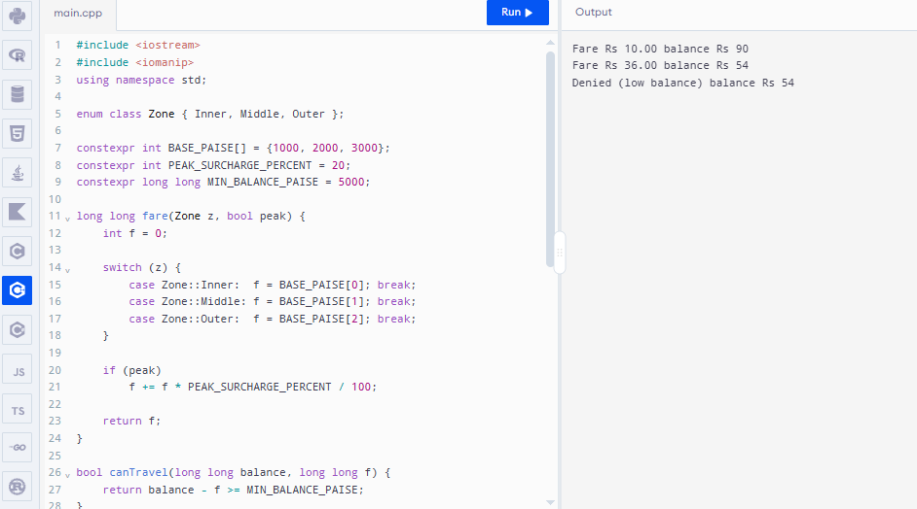

TASK 7 – From Procedural to Object-Oriented 4 Marks
Bloom’s Level: K5 – Evaluate
Rewrite the fare logic in two styles.
Discuss:
• A procedural version with separate variables and free functions
• An object-oriented version with a SmartCard class that keeps its balance private and offers deduct() and canTravel()
• How the class prevents a negative balance
• Which version is easier to change when the minimum balance changes Alternative Concept and Complexity Analysis
If the balance were kept in a public data member instead of a private member with deduct() and canTravel(), what would the solution be? Analyse whether time or space changes (they do not), and explain which rule of the system can then be broken by any part of the program.
Evidence Expected
Two working versions and a reasoned comparison of the procedural and object-oriented designs.

#include <iostream>
using namespace std;

// Procedural version
double balance = 200;

bool canTravel(double balance, double fare)
{
return balance - fare >= 50;
}

void deduct(double &balance, double fare)
{
if (canTravel(balance, fare))
{
balance -= fare;
cout << "Travel allowed. Balance: Rs." << balance << endl;
}
else
cout << "Insufficient balance!" << endl;
}

// Object-oriented version
class SmartCard
{
private:
double balance;

public:
SmartCard(double b)
{
balance = b;
}

bool canTravel(double fare)
{
return balance - fare >= 50;
}

void deduct(double fare)
{
if (canTravel(fare))
{
balance -= fare;
cout << "Travel allowed. Balance: Rs."
<< balance << endl;
}
else
cout << "Insufficient balance!" << endl;
}
};

int main()
{
cout << "Procedural Version\n";
deduct(balance, 80);

cout << "\nObject-Oriented Version\n";
SmartCard card(200);
card.deduct(80);

return 0;
}
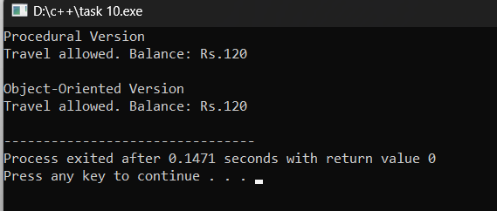

TASK 8 – Read and Print Data Safely 4 Marks
Bloom’s Level: K5 – Evaluate
Design the input and output of the gate program.
Discuss:
• Reading values with cin and checking cin.fail() when the operator types letters instead of numbers
• Clearing the error state with cin.clear() and discarding the bad input • Formatting money with <iomanip> (setw, setfill, fixed, setprecision)
• Printing a neat journey report
Alternative Concept and Complexity Analysis
If each input line were read with std::getline() and converted with std::stoi() inside try/catch, instead of reading numbers directly with cin >>, what would the solution be? Analyse the time to process a line of length L (O(L) in both) and the buffer space needed, and compare how each recovers from invalid input.
Evidence Expected
Safe input handling with demonstrated recovery from invalid input, and correctly formatted output.

#include <iostream>
#include <iomanip>
#include <limits>
using namespace std;

int main()
{
int zone;
double fare, balance = 200;

cout << "Enter zone number (1-3): ";

while (!(cin >> zone))
{
cout << "Invalid input! Enter a number: ";
cin.clear();
cin.ignore(numeric_limits<streamsize>::max(), '\n');
}

if (zone < 1 || zone > 3)
{
cout << "Invalid zone!" << endl;
return 0;
}

fare = zone * 20;

cout << "\n----- Journey Report -----\n";
cout << left << setw(20) << "Zone" << zone << endl;
cout << left << setw(20) << "Journey Fare"
<< "Rs. " << fixed << setprecision(2)
<< fare << endl;
cout << left << setw(20) << "Previous Balance"
<< "Rs. " << balance << endl;
cout << left << setw(20) << "Remaining Balance"
<< "Rs. " << balance - fare << endl;

return 0;
}
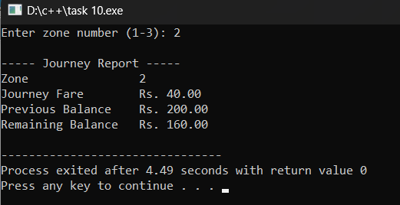

TASK 9 – Implement and Test the Fare Logic 4 Marks
Bloom’s Level: K5 – Evaluate
Implement the complete fare logic and test it.
Test:
• Normal journeys in each zone, peak and off-peak
• Boundary cases: exactly 8:00, 10:00, 17:00 and 20:00; a balance that leaves exactly Rs 50 • Invalid cases: an unknown zone, a negative recharge, letters typed for the hour • A small set of 5 journeys whose total you calculate by hand
Alternative Concept and Complexity Analysis
If each journey were tested against a table of test cases (inputs and expected fares) in a loop, instead of separate hand-written checks, what would the solution be? Analyse the time for t tests (O(t)) and the space of the table, and how easily a new boundary case can be added.
Evidence Expected
Working source code and a test table with expected and actual results for every case.
#include <iostream>
#include <iomanip>
using namespace std;

int main()
{
int zone, hour;
double balance = 200, fare;
double total = 0;

for (int i = 1; i <= 5; i++)
{
cout << "\nJourney " << i << endl;
cout << "Enter zone (1-3): ";
cin >> zone;

if (cin.fail())
{
cout << "Invalid zone input!" << endl;
return 0;
}

if (zone < 1 || zone > 3)
{
cout << "Unknown zone!" << endl;
return 0;
}

cout << "Enter hour (0-23): ";
cin >> hour;

if (cin.fail())
{
cout << "Invalid hour input!" << endl;
return 0;
}

if (hour < 0 || hour > 23)
{
cout << "Invalid hour!" << endl;
return 0;
}

fare = zone * 20;

if ((hour >= 8 && hour < 10) ||
(hour >= 17 && hour < 20))
fare += 10;

if (balance - fare >= 50)
{
balance -= fare;
total += fare;

cout << fixed << setprecision(2);
cout << "Fare: Rs. " << fare << endl;
cout << "Balance: Rs. " << balance << endl;
}
else
{
cout << "Insufficient balance!" << endl;
break;
}
}

cout << "\n----- Final Report -----\n";
cout << "Total Fare: Rs. " << total << endl;
cout << "Remaining Balance: Rs. " << balance << endl;

return 0;
}
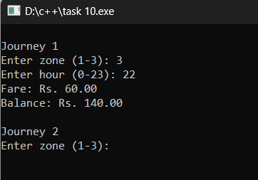
TASK 10 – Compare Expectations with Execution 4 Marks
Bloom’s Level: K5 – Evaluate
Compare what you expected with what actually happened.
Discuss:
• Whether the double and integer-paise totals for 20,000, 500,000 and 3,000,000 journeys agree, and by how much they differ
• Whether int overflows for the network total
• The compiler warnings you received with -Wall -Wextra and what each meant • Reasons for any difference
Alternative Concept and Complexity Analysis
If the network total were accumulated in an int, a long long or a double, what would happen at 3,000,000 journeys? Analyse when each type fails (overflow versus loss of precision), and compare the time per addition and the space per variable.
Evidence Expected
A reasoned comparison of expected and observed behaviour, supported by measured totals.

Program:

#include <iostream>
using namespace std;

int main() {
int journeys[] = {20000, 500000, 3000000};

for (int n : journeys) {
long long totalPaise = 1LL * n * 3000;
double totalRupees = n * 30.0;

cout << "Journeys: " << n << endl;
cout << "Integer paise: " << totalPaise << endl;
cout << "Double rupees: " << totalRupees << endl;
cout << "Int limit exceeded: "
<< (totalPaise > 2147483647LL ? "Yes" : "No")
<< endl << endl;
}

return 0;
}

Output:
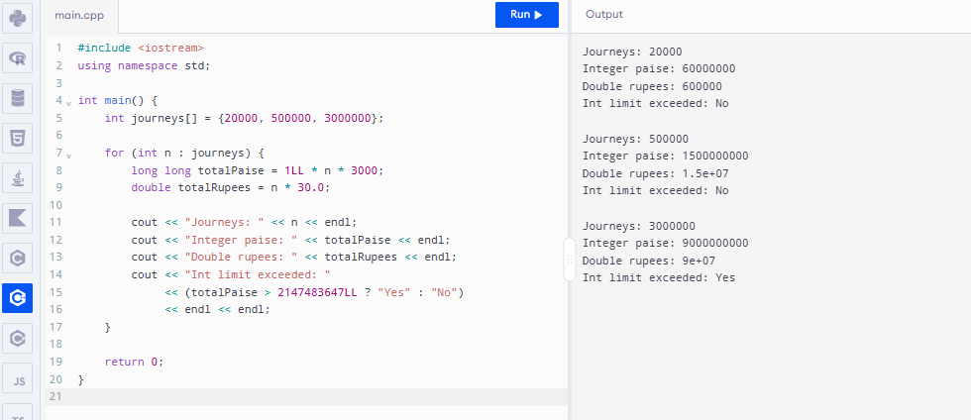

TASK 11 – Recommend and Defend the Final Design 4 Marks
Bloom’s Level: K5 – Evaluate
Recommend the final design for the metro.
Discuss:
• The types, constants and classes you recommend and why
• How a fare revision will be carried out
• The limitations of your design
• Whether the design remains correct for the whole network
Your recommendation must be based on evidence from your own experiments. Alternative Concept and Complexity Analysis
If the fare table were read from a configuration file when the gate starts, instead of being compiled into the program, what would the solution be? Analyse the extra start-up time to read z fare values and the space they occupy, against the cost of recompiling and redeploying after every revision.
Evidence Expected
A technically justified recommendation supported by your tests and measurements.

Program:

#include <iostream>
using namespace std;

constexpr long long MIN_BALANCE = 5000;

class SmartCard {
long long balance;

public:
SmartCard(long long b) : balance(b) {}

bool canTravel(long long fare) {
return fare >= 0 && balance - fare >= MIN_BALANCE;
}

void deduct(long long fare) {
if (canTravel(fare)) {
balance -= fare;
cout << "Journey accepted" << endl;
} else {
cout << "Journey denied" << endl;
}
}

void showBalance() {
cout << "Balance Rs " << balance / 100
<< "." << (balance % 100 < 10 ? "0" : "")
<< balance % 100 << endl;
}
};

int main() {
SmartCard card(10000);

card.deduct(3000);
card.showBalance();

card.deduct(6000);
card.showBalance();

return 0;
}

Output:
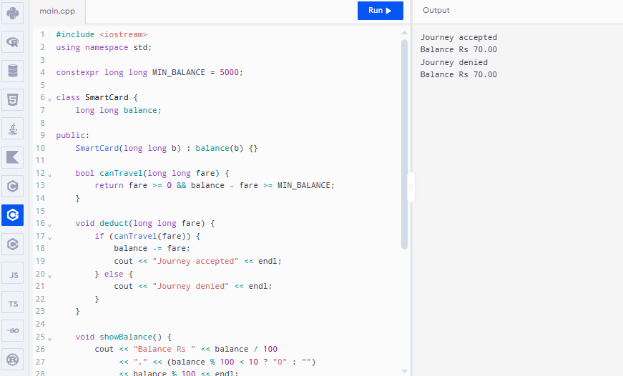

TASK 12 – Re-evaluate and Adapt the Design 8 Marks
Bloom’s Level: K5 – Evaluate
Changed Requirement
The metro adds a fourth zone (Airport, Rs 60), a 10% weekend discount that does not combine with the peak surcharge, and a monthly pass that allows unlimited journeys in two chosen zones.
Re-evaluate your original design. You may RETAIN → MODIFY → or REDESIGN your original solution. A. Impact Analysis – 2 Marks
Identify which constants, enum values, expressions, switch statements and classes are affected. Evidence Expected
A clear analysis of how the changed requirements affect the original design. B. Evaluation of the Original Design – 2 Marks
Evaluate whether the switch-based fare logic and the SmartCard class can absorb the changes, using worked examples.
Evidence Expected
A technically supported evaluation of the original design.
C. Adaptation or Redesign – 2 Marks
Describe and implement the revised design (for example: a fare table indexed by zone, a separate discount rule, a Pass class).
Evidence Expected
An appropriate design response with working code.
D. Evidence-Based Defence – 2 Marks
Defend your decision using test results and the trade-offs involved.
Evidence Expected
A well-supported final decision integrating tests and the changed requirements.
MARK DISTRIBUTION
Task Bloom’s Level Marks

Program:

#include <iostream>
using namespace std;

enum class Zone { Inner, Middle, Outer, Airport };

constexpr int FARE[] = {1000, 2000, 3000, 6000};

class Pass {
public:
Zone z1, z2;

Pass(Zone a, Zone b) : z1(a), z2(b) {}

bool valid(Zone z) {
return z == z1 || z == z2;
}
};

long long calculateFare(Zone z, bool peak, bool weekend) {
long long f = FARE[static_cast<int>(z)];

if (weekend)
f = f * 90 / 100;
else if (peak)
f = f * 120 / 100;

return f;
}

int main() {
Pass pass(Zone::Middle, Zone::Airport);

cout << "Airport peak fare: Rs "
<< calculateFare(Zone::Airport, true, false) / 100.0
<< endl;

cout << "Outer weekend fare: Rs "
<< calculateFare(Zone::Outer, true, true) / 100.0
<< endl;

cout << "Monthly pass for Airport: "
<< (pass.valid(Zone::Airport) ? "Valid" : "Invalid")
<< endl;

cout << "Monthly pass for Outer: "
<< (pass.valid(Zone::Outer) ? "Valid" : "Invalid")
<< endl;

return 0;
}

Output:
